Scoil Ursula National School

Acceptable Use Policy
The aim of this Acceptable Use Policy is to ensure that pupils will benefit from learning opportunities offered by the school’s Internet resources in a safe and effective manner. Internet use and access is considered a school resource and privilege. Therefore, if the school AUP is not adhered to this privilege will be withdrawn and appropriate sanctions – as outlined in the AUP – will be imposed.

It is envisaged that school and parent representatives will revise the AUP annually and update if deemed necessary. Before signing, the AUP should be read carefully to ensure that the conditions of use are accepted and understood.

This version of the AUP was updated in October 2022

School’s Strategy
The school employs a number of strategies in order to maximise learning opportunities and reduce risks associated with the Internet. These strategies are as follows:

General
- Internet sessions will always be supervised by an adult.
- Filtering software and/or equivalent systems will be used in order to minimise the risk of exposure to inappropriate material.
- Filtering level *** through NCTE.
- The school will regularly monitor pupils’ Internet usage.
- Students and teachers will be provided with training in the area of Internet safety annually during Safer Internet Week.
- Uploading and downloading of non-approved software will not be permitted.
- The use of personal memory sticks, CD-ROMs, or other digital storage media in school requires a teacher’s permission.
- Students will treat others with respect at all times and will not undertake any actions that may bring the school into disrepute.

World Wide Web
- Students will not intentionally visit Internet sites that contain obscene, illegal, hateful or otherwise objectionable materials.
- Students will report accidental accessing of inappropriate materials in accordance with school procedures.
- Students will use the Internet for educational purposes only.
- Students will be made aware of appropriate ways to use information sourced online in order to discourage plagiarism and copyright infringement.
- Downloading materials or images not relevant to their studies is in direct breach of the school’s acceptable use policy.
- Students will be aware that any usage, including distributing or receiving information, school-related or personal, may be monitored for unusual activity, security and/or network management reasons.
- Students will not reveal their own or other people’s personal details, such as addresses or telephone numbers or pictures.
- Students will never arrange a face-to-face meeting with someone they only know through emails or the Internet.
- Students will not access chat rooms, discussion forums, messaging or other electronic communication without supervision and the express permission of their teacher.

School Website
- Pupils will be given the opportunity to have their work published on the World Wide Web in accordance with clear policies and approval processes regarding the content that can be loaded to the school’s website
- The publication of student work will be co-ordinated by the teacher in charge of the school website.
- The school will endeavour to use digital photographs, audio or video clips focusing on group activities. Content focusing on individual students will not contain pupils’ names.
- Personal pupil information including home address and contact details will be omitted from school web pages.
- The school website will avoid publishing the first name and last name of individuals in a photograph.
- The school will ensure that the image files are of groups of two pupils at least and are appropriately named – the school will avoid using pupils’ names in image file names or ALT tags if published on the web.
- Pupils will continue to own the copyright on any work published.

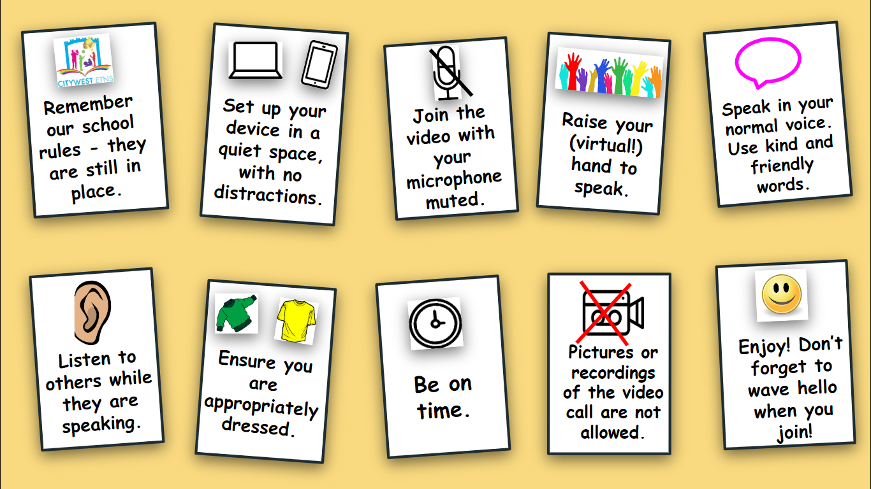

Guidelnes

Under no circumstances can pictures or recordings be taken of video calls by students.

Staff, families and students are expected to behave in an appropriate, safe, respectful and kind manner online.

It is the duty of parents/guardians to supervise children while they are working online and to ensure any content which they are submitting to their teacher is appropriate.

Staff members can communicate with pupils and their families via Aladdin or through an established app (eg. Seesaw, Class Dojo).

Any electronic forms of communication will be for educational purposes and to allow for communication with families.

Students and staff will communicate using tools which have been approved by the school and of which parents have been notified (Seesaw, Zoom, Classdojo, gmail, Aladdin)

Parental permission will be acquired before setting up a profile for a pupil on a communication forum.

For video/Zoom calls, parental permission is implied, as the link to a video call will be communicated via the parent/guardian’s email address. Essentially, by virtue of the pupil logging on to the call, permission is assumed.

For security reasons, passwords will be provided to families, where applicable.

Scoil Ursula National School cannot accept responsibility for the security of online platforms, in the event that they are hacked.

Communication using a mobile phone will not be frequent, but in the rare exception where it is necessary, staff members can ensure that their caller ID is private.

Guidelines for staff members using online communication methods:

Under no circumstances can pictures or recordings be taken of video calls without notifying the group first. Staff meetings may be recorded in the case where a staff member cannot attend.

Staff members will communicate with pupils and families during the hours of 8.30am - 5pm, where possible.

Staff members will have high expectations regarding pupil behaviour, with any communication which takes place online.

Staff members will seek to become familiar with apps before using them with pupils.

Staff will check that consent has been given, before setting up a pupil profile for an online app.

Staff members will report any concerns regarding online behaviour or interactions to school management.

Staff members will notify parents/guardians of the date, time and password for a video call via email.

Staff members will only admit participants to video conferences, if they recognise the email address/username as being connected to a pupil.

Rules for pupils using online communication methods:

For submitting learning:

Submit work and pictures that are appropriate - have an adult take a look at your work before you send it.

Use kind and friendly words.

For video calls/Zoom:

Pictures or recordings of the video call are not allowed.

Remember our school rules - they are still in place, even online.

Set up your device in a quiet space, with no distractions in the background.

Join the video with your microphone muted.

Raise your hand before speaking, just like you would do in class.

If you have the chance to talk, speak in your normal voice, using kind and friendly words.

Show respect by listening to others while they are speaking.

Ensure that you are dressed appropriately for the video call.

Be on time - set a reminder if it helps.

Enjoy! Don’t forget to wave hello to everyone when you join!

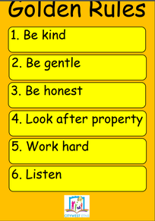

Guidelines for parents and guardians:

For learning

It is the responsibility of parents and guardians to ensure that pupils are supervised while they work online.

Check over the work which pupils send to their teacher, ensuring it is appropriate.

Continue to revise online safety measures with pupils.

For video calls/Zoom

Under no circumstances can pictures or recordings be taken of video calls.

Ensure that the school has the correct email address for inviting you to join apps and meetings.

The main purpose of a video call is to maintain a social connection between the school staff and pupils at this difficult time. Encourage pupils to listen and enjoy the experience.

Be aware that when participating in group video calls, you can be seen and heard unless you are muted or have disabled your camera.

You will automatically enter a waiting room when the code for a Zoom call has been entered. Please note that school staff will only accept users into video call if you can be identified by the display name on your zoom account.

Please ensure that your child is on time for a scheduled video, or they may be locked out. Please request to join the Zoom call approximately five minutes before the scheduled start time. This will give school staff time to verify your email address.

Make sure to familiarise your child with the software in advance. For video in particular, show them how to mute/unmute and turn the camera on/off.

Participants in the call should be dressed appropriately.

An appropriate background/room should be chosen for the video call.

For detailed information on GDPR and Zoom, please visit https://zoom.us/privacy

Personal Devices
Pupils are not permitted to use mobile phones / camera phones or any other devices that can take or store images or video material in the school or on school tours.

Legislation
The school draws your attention to the following legislation relating to use of the Internet which teachers, students and parents should familiarise themselves with:
- Circular Number: 0074/2020 Communication/Teaching & Learning Platform
- Child Trafficking and Pornography Act 1998
- Interception Act 1993
- Video Recordings Act 1989
- The Data Protection Act 1988

Sanctions
Misuse of the Internet may result in disciplinary action, including written warnings, withdrawal of access privileges and, in extreme cases, suspension or expulsion. The school also reserves the right to report any illegal activities to the appropriate authorities.

Signed: ___________________ Signed: _______________

Principal ICT Co-ordinator

Scoil Ursula Internet Acceptable Use Policy.

Reviewed: October 2022
Please read our Internet Acceptable Use Policy (attached), sign and return this permission form to the Secretary.

Name of Pupil: _____________________ Class: __________________

Pupil
I agree to follow the school’s Acceptable Use Policy on the use of the Internet. I will use the Internet in a responsible way and obey all the rules explained to me by the school.

Pupil’s Signature: __________________________ Date: _____________

Parent/Guardian
As the parent or legal guardian of the above pupil, I have read the Acceptable Use Policy and grant permission for my son or the child in my care to access the Internet. I understand that Internet access is intended for educational purposes. I also understand that every reasonable precaution has been taken by the school to provide for online safety but the school cannot be held responsible if pupils access unsuitable websites.

I accept the above paragraph □ I do not accept the above paragraph □
(Please tick as appropriate)

In relation to the school website, I accept that, if the school considers it appropriate, my child’s schoolwork may be chosen for inclusion on the website. I understand and accept the terms of the Acceptable Use Policy relating to publishing children’s work on the school website including the use of photographs, video and audio files produced following the AUP guidelines.

I accept the above paragraph □ I do not accept the above paragraph □
(Please tick as appropriate)

Signature: _________________________ Date: ___________________

Address: __________________________ Phone: ___________________

